**i**

**EXAMPLE 1 : SHELL SCRIPT TO DISPLAY CURRENT TIME**

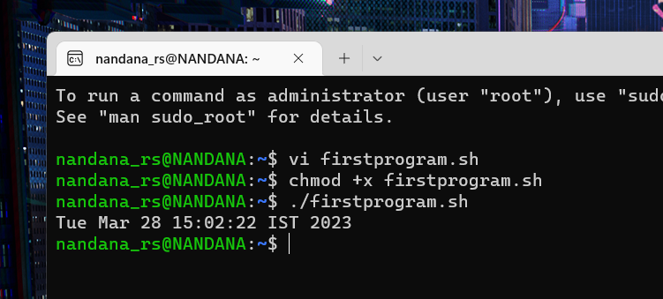

**EXAMPLE 2 : SHELL SCRIPT TO DISPLAY YOUR NAME**



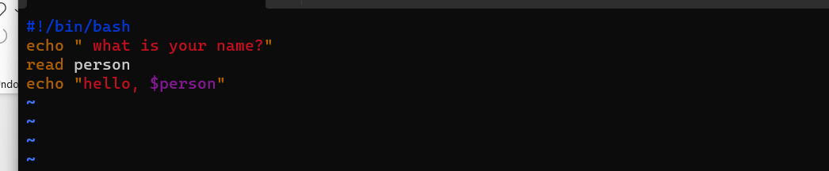

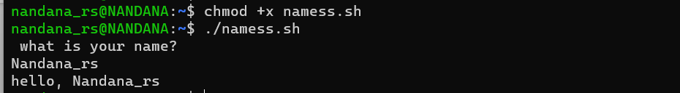

3.SHELL SCRIPT TO DEMONSTARTE VARIABLE

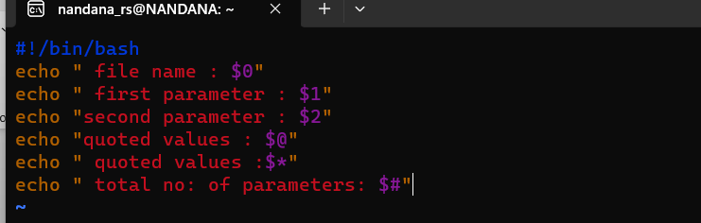

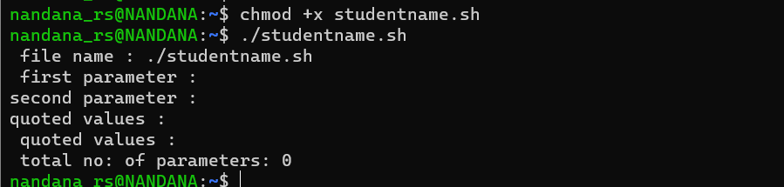

4. SHELL SCRIPT TO count lineea



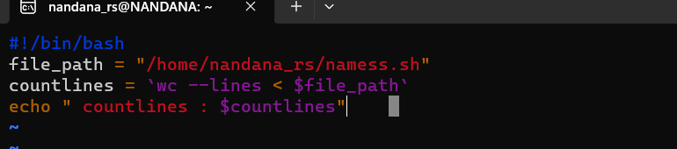

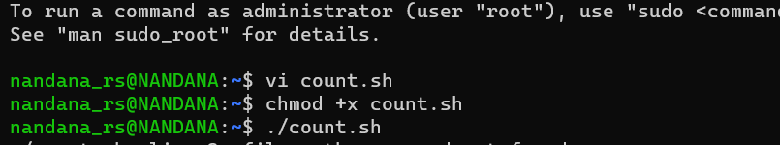

5.SHELL SCRIPT TO DISPLAY AN ARRAY



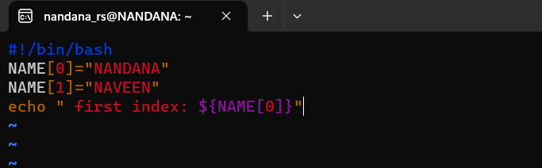

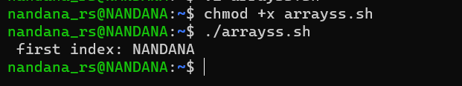

**Date : 3/4/2023**

**EXAMPLE 7: Shell Script to add two numbers**



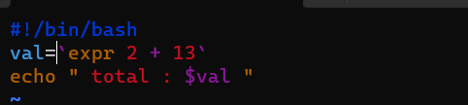

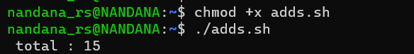

**Write an example shell script to initialize 2 numeric variables.Then perform an addition operation on both values and store results in third variable**



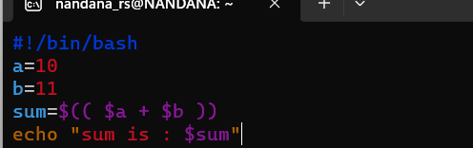

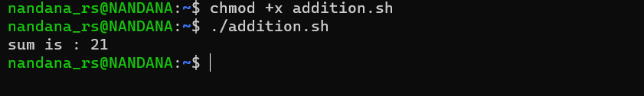

**Shell script reads 2 numbers as command lines parameters and performs the addition operation**



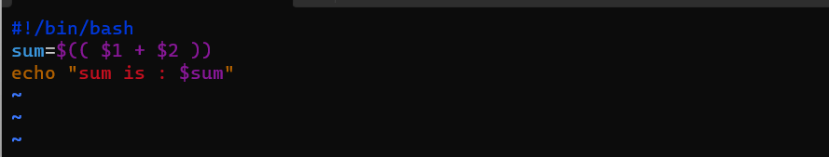



**Shell script that input from user at run time. Then calculate sum of given numbers and calculator**



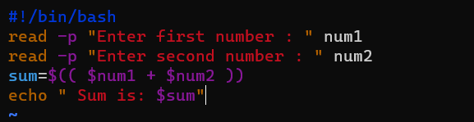

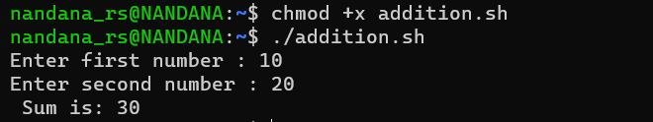

**Calculator**



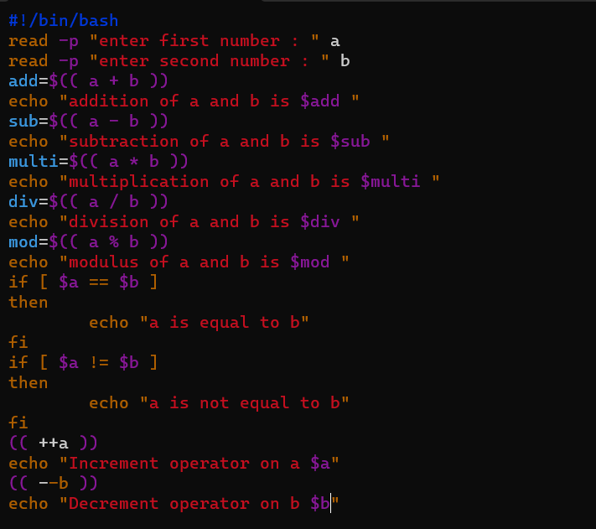

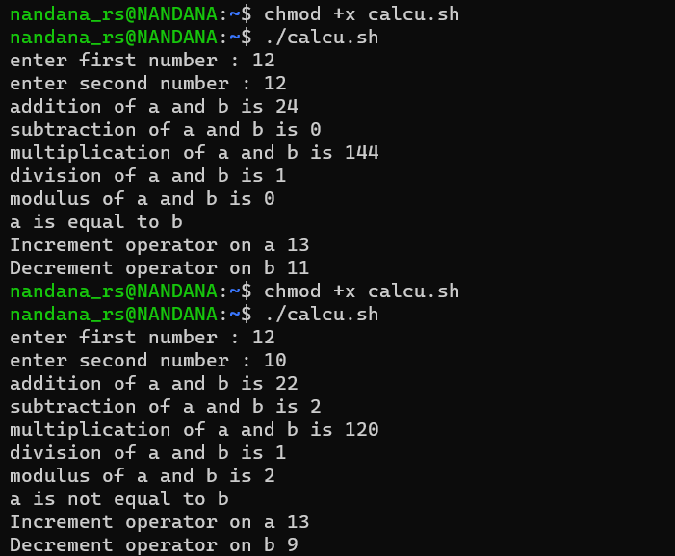

**RELATIONAL OPERATORS**



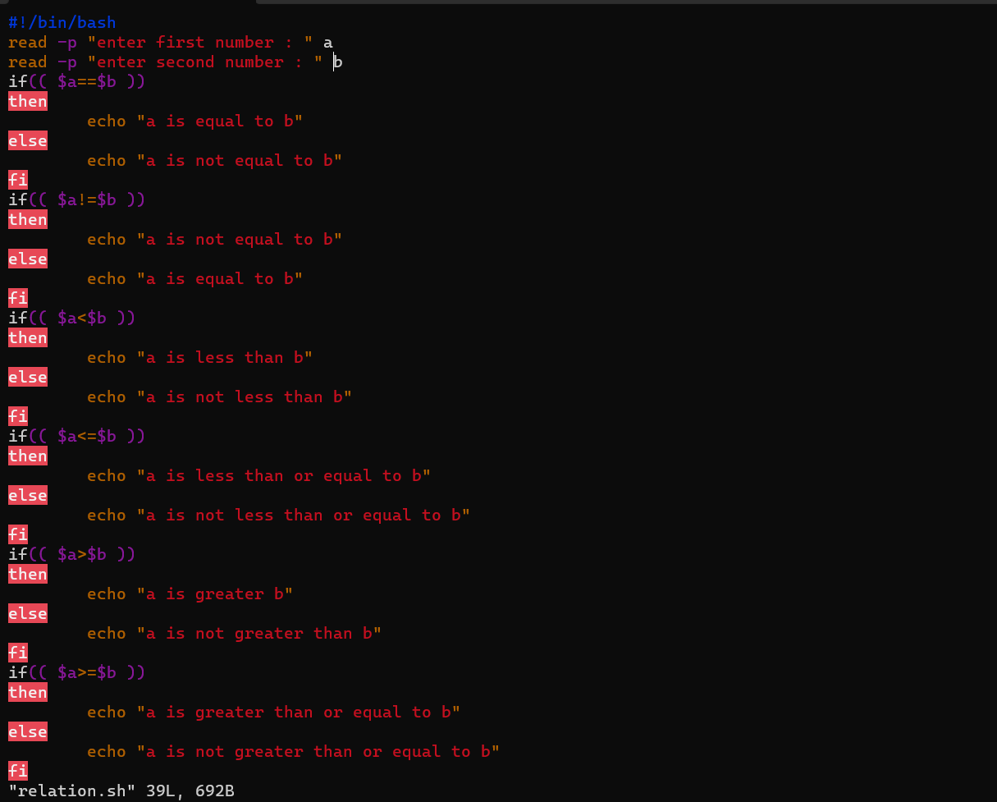

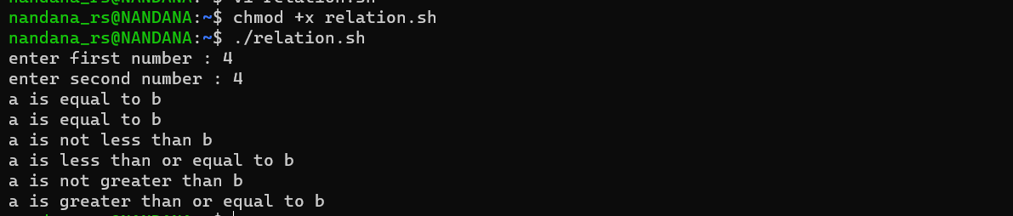



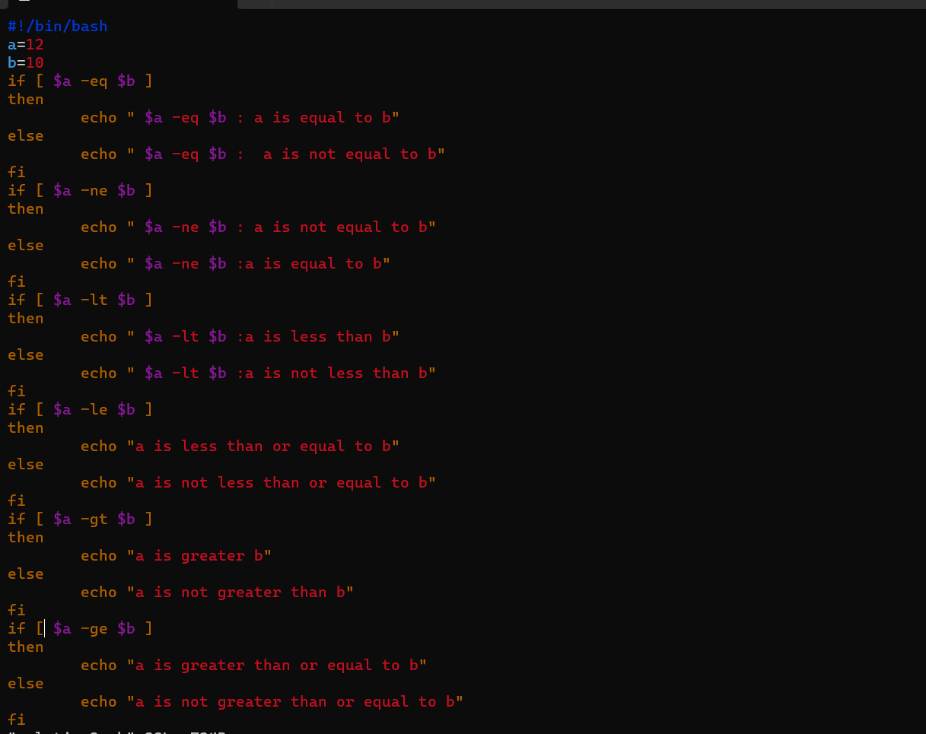

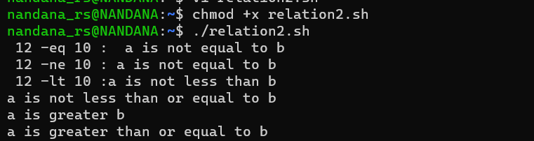

**Shell script to display odd or even**



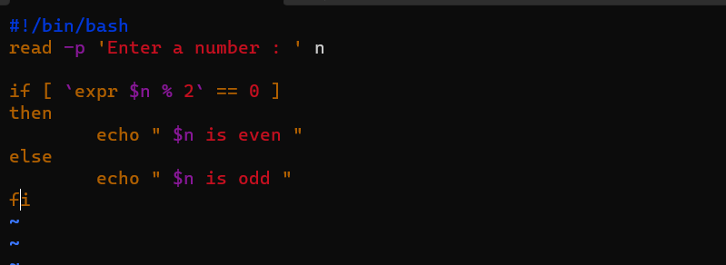

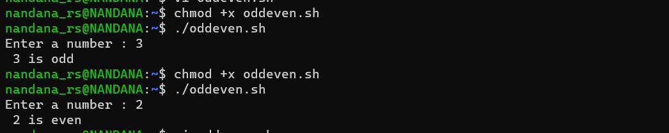

**Shell script to demonstrate whether a number is positive or negative**



